Agenda-Create a db of questions as per requirement. Create question paper, Ensure in a question paper automatically, 50% of questions should be medium complexity, 25% with low complexity and another 25% must be high complexity

Create One data type and add records

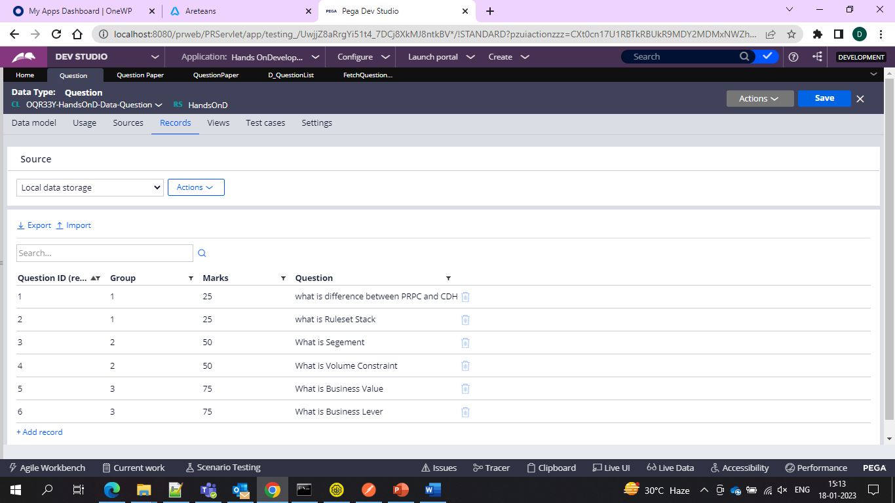

And create one case type 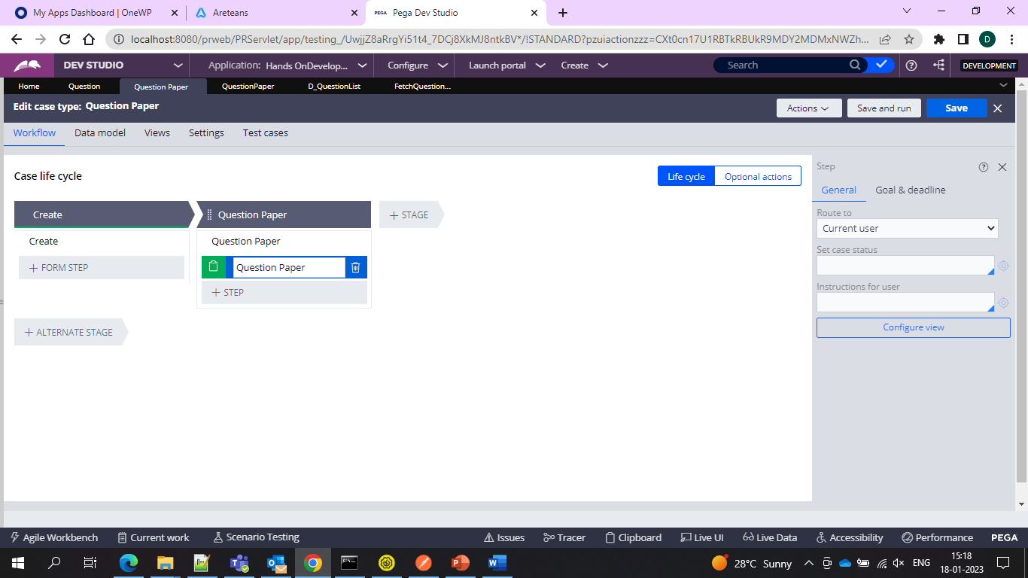

And then configure section

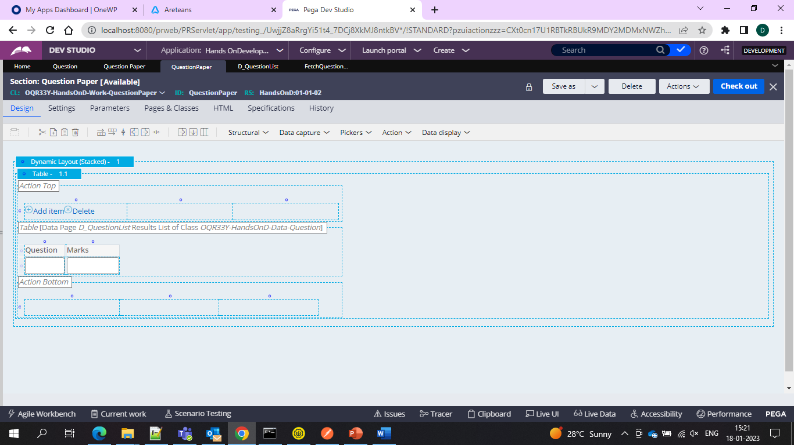

And inside that use list data page for the table source

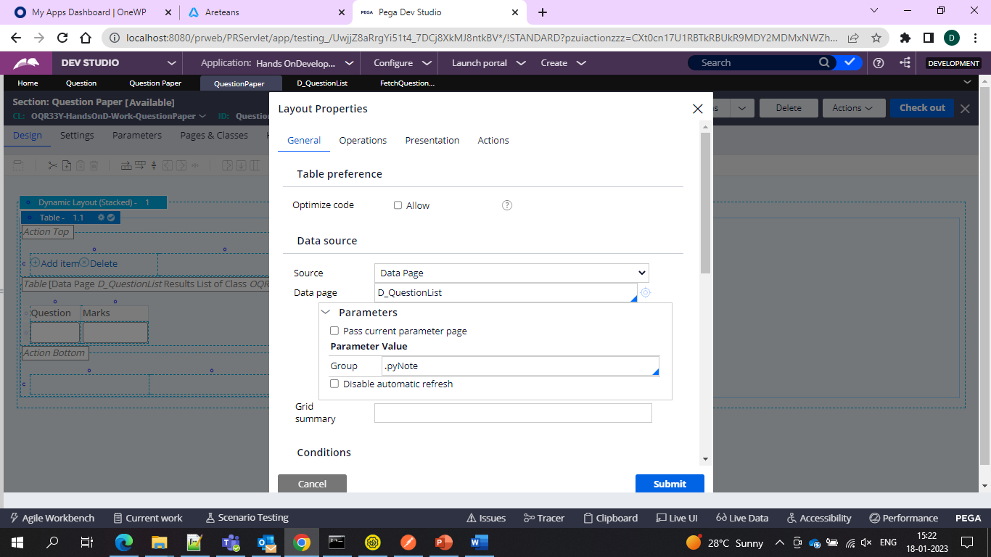

And then parameter as the group and assign to pyNote so that it can capture

And after that we create one report definition

And apply the marks which are above 25 and save and show in the section and on the UI

And now we would only get the Marks list above the age of 25

